Miami-Dade County Public Schools
Department of Secondary English Language Arts

DISTRICT WRITING PRE-TEST ASSESSMENT

6TH GRADE
INFORMAtive/eXPLANATORY PROMPT

Name: ____________________________
Teacher: ______________ Per: ____
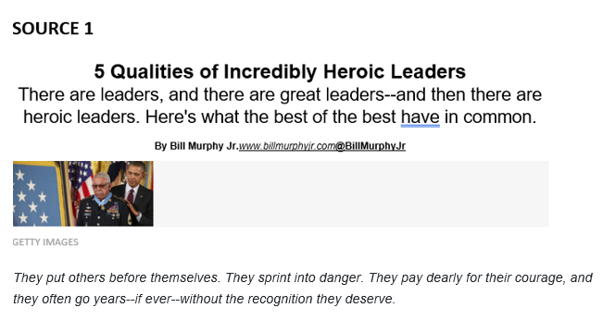
1 | "Their courage almost defies imagination," President Obama said at a ceremony honoring 24 heroes whose awards were delayed for years because of prejudice and bureaucratic¹ ineptitude². He's right, but we can also find similarities in their stories, and inspiration. While few of us are called to rush into oncoming bullets, we make choices every day about whether to act heroically or ordinarily.
 | 1. Courage
2 | Courage and bravery leap to mind first when we think of heroism. It's difficult to achieve anything truly heroic unless you're up against daunting odds. As Nelson Mandela put it, "Courage is not the absence of fear, but the triumph over it."
3 | Marine Corporal Kyle Carpenter literally dove on a grenade to protect a fellow Marine during an attack in Afghanistan in November 2010. Both men survived but were badly wounded. After a military investigation into exactly what happened, Carpenter will receive the Medal of Honor at a ceremony later this year.
4 | 2. Selflessness  True leaders always put others first. Ironically, that kind of selflessness can often be strategic, because focusing on others' needs often winds up helping you achieve your own goals. However, a heroic leader does so without any expectation of payback.
5 | During the Korean War, an army private named Leonard Kravitz voluntarily stayed behind to cover the retreat of other soldiers in his unit. Remaining as the last line of defense saved his entire platoon, but it also cost him his life on March 7, 1951. It took until this year for him to be recognized posthumously³ for his heroism with the Medal of Honor.
6 | 3. Humility  Nothing makes a heroic leader seem a little less heroic than if he or she seems to want constant credit for his or her actions. True heroism can amaze us, but it also often contains a component of modesty.
7 | Sargent Santiago Erevia received the Medal of Honor earlier this year as a result of his heroism in Vietnam in 1969. During 32 years after he left the military, however, while he carried mail for the U.S. Postal Service, he never talked much about his military service--despite the fact that he'd already been awarded the Distinguished Service Cross, the military's second-highest honor.
8 | 4. Patience  While heroism often requires quick thinking and decisiveness, truly heroic leaders often also display an impressive amount of patience.
9 | In September 1969, Melvin Morris was a special forces sergeant serving in Vietnam, and he led a mission across enemy lines to rescue a fellow U.S. soldier. Along the way he "single-handedly destroyed an enemy force that had pinned his battalion from a series of bunkers ... [and] was shot three times as he ran back toward friendly lines with the American casualties⁴."
10 | "Better late than never," Morris told a newspaper. The newspaper also reported that like other heroes, Morris had never talked much about his military service, "out of respect for the gravity of taking a human life."
11 | 5. Caring  Separate from selflessness, heroic leaders display a sense of concern and kindness for others. This can often manifest itself in strong but gentle actions intended to improve the lives of others. These are small acts of heroism that rarely attract any notice.
12 | Army veteran Jose Rodela received the Medal of Honor earlier this year for his valor during an 18-hour battle in Vietnam in September 1969. However, Rodela was also known for having taken in a 12-year-old Cambodian orphan his unit had found living alone. Rodela made plans to adopt the boy and bring him back to his family in the United States, although the boy unfortunately was later killed when he stepped on a mine.

 | Heroes are known for their bravery.
13 | Whether it's saving someone from a burning vehicle or after they fall on to train tracks, thousands of people risk their lives helping others each year.
14 | But does anything set these people apart?
15 | Risk-takers  Berkeley Johnson helped rescue a two-year-old from under several feet of debris following the California mudslides and was labelled a hero.
16 | Berkeley decided to leave the relative safety of his roof to wade through deep mud, passing "boulders the size of vans", in search of help.
17 | If he hadn't, the toddler may never have been found.
18 | And it's that sort of risk-taking that's an important trait, according to Dr Punit Shah, from the University of Bath's Department of Psychology.
19 | "People that act quickly and are more impulsive are more likely to engage in acts of heroism," he says.
20 | Other traits may include "people that value other humans, that have good moral values - and also people that value social status".
21 | The empathy balance  Having a naturally caring side doesn't always mean you'll be leaping into action.
22 | "If you are overly empathetic¹, if you do put yourself into a person's shoes a bit too much and allow that emotional response to kick in, it might then prevent you from helping," Dr Shah says.
23 | "Some people who are too empathetic can be distressed at seeing other people in pain, at seeing the world as a horrible place, and that means that they can't do anything.
24  25 | "They're so overwhelmed with someone else's suffering it actually impacts on them."  Dr Shah says more research needs to be done, especially on the relationship between empathy and heroism, but something is standing in the way.
26 | "We often report on acts of heroism where the person survives, but there are many cases where heroes are hurt and do die.
27 | "It means that we can't do as much research and work on heroism as we'd like because actually we have this almost biased view of 'heroes always survive' - but there are many heroes that don't".  1-considerate, kind

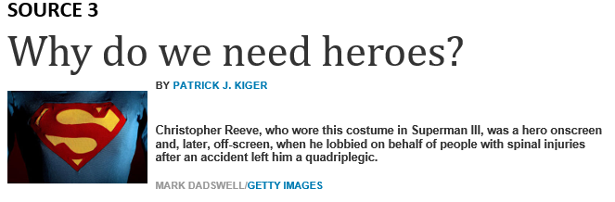
28 | In the epic poem "The Odyssey," which was written in the 8th century B.C., Greek warrior Odysseus becomes lost on his way home from the 10-year-long Trojan War and spends an additional 10 years fighting monsters and sorcerers and resisting temptations -- all so he can return home to protect his wife and family from men who are attempting to steal their fortune. During the story, Odysseus unflinchingly accepts divine punishment for his men's misdeeds, and relies on his guile and determination to survive. Most importantly, even though Odysseus knows the gods control his fate, he fearlessly struggles to return home to save the ones he loves.
29 | To the Greeks, Odysseus was a hero, a word that is derived from the Ancient Greek term for "protector." But he was more than just that. The brave captain embodied the virtues and attributes that Greek society cherished and he provided a model for Greek people to emulate.
30 | These days, some of our champions are soldiers who've shown valor in war, and astronauts who've risked their lives to explore space. We also see heroism in people who make life-saving medical discoveries, dedicate their careers to helping the poor and underprivileged, or labor to right social injustices. Therefore, in a greater sense, polio conqueror Dr. Jonas Salk, Mother Theresa and Martin Luther King, Jr., have a lot in common with ancient Odysseus.
31 | Still, certain qualities tend to stand out as particularly heroic. For example, a Cornell University business school study of 526 World War II combat veterans found that the 83 individuals who were decorated for battlefield valor described themselves as loyal, self-disciplined, selfless and adventurous. Other researchers have identified those same characteristics in leaders who transform organizations and societies.
32 | Heroes are often brave and capable of leading others, and they resolve problems that confront society. They also tend to be risk-takers. According to Temple University educational psychology professor Frank Farley, many heroic historical figures (think Franklin D. Roosevelt and Martin Luther King) are habitual thrill-seekers who don't hesitate to place themselves in personal danger to accomplish a goal. Since many people don't take huge risks, they admire this quality in another person, and are even drawn to follow him or her.

Any cause needs speakers and organizers. Any mass movement requires men and women of great ideas.
33 | But information and mobilization are not enough. To be successful, revolutionary change requires people of action — those who little by little chip away at the forces who stand in the way. Such were the "conductors" of the UNDERGROUND RAILROAD. Not content to wait for laws to change or for slavery to implode itself, railroad activists helped individual fugitive slaves find the light of freedom.
34 | The Underground Railroad operated at night. Slaves were moved from "station" to "station" by abolitionists. These "stations" were usually homes and churches — any safe place to rest and eat before continuing on the journey to freedom, as faraway as Canada. Often whites would pretend to be the masters of the fugitives to avoid capture. Sometimes lighter skinned African Americans took this role. In one spectacular case, HENRY "BOX" BROWN arranged for a friend to put him in a wooden box, where he had only a few biscuits and some water. His friend mailed him to the North, where bemused abolitionists received him in Philadelphia.
35  36 | Most of the time, however, slaves crept northward on their own, looking for the signal that designated the next safe-haven. This was indeed risky business, because SLAVE CATCHERS and sheriffs were constantly on the lookout. Over 3,200 people are known to have worked on the railroad between 1830 and the end of the Civil War. Many will remain forever anonymous.  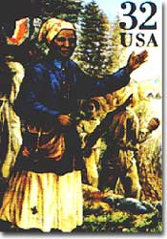  Perhaps the most outstanding "conductor" of the Underground Railroad was HARRIET TUBMAN. Born a slave herself, she began working on the railroad to free her family members. During the 1850s, Tubman made 19 separate trips into slave territory. She was terribly serious about her mission. Any slave who had second thoughts she threatened to shoot with the pistol she carried on her hip. By the end of the decade, she was responsible for freeing about 300 slaves. When the Civil War broke out, she used her knowledge from working the railroad to serve as a spy for the Union.  Harriet Tubman is sometimes referred to as the Moses of her people because of the way she led them out of slavery.

Writing Prompt
Your school would like to recognize students as community heroes. Write an explanatory essay to inform the students in your school about what makes a person a hero. Your essay must be based on ideas and information that can be found in the passage set.

Manage your time carefully so that you can
• read the passages;
• plan your response;
• write your response; and
• revise and edit your response.
Be sure to
• use evidence from multiple sources; and
• avoid overly relying on one source.
Your response should be in the form of a multi-paragraph essay. Write your response in the space provided.

